38.26: a) We can find the photon’s energy from Eq. 38.8
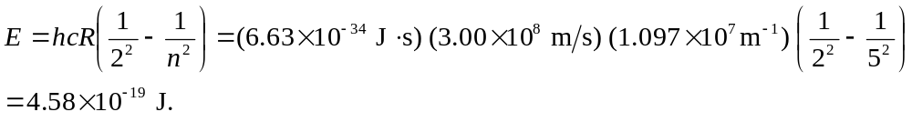
The corresponding wavelength is 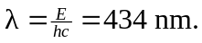
b) In the Bohr model, the angular momentum of an electron with principal quantum number n is given by Eq. 38.10
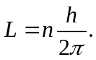
Thus, when an electron makes a transition from n = 5 to n = 2 orbital, there is the following loss in angular momentum (which we would assume is transferred to the photon):
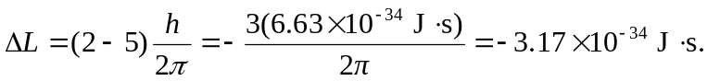
However, this prediction of the Bohr model is wrong (as shown in Chapter 41).

